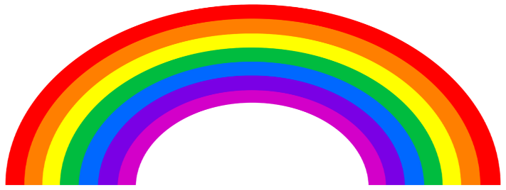
Welcome to South Africa !

Where is South Africa ?

South Africa is located of the South of the African continent. Its capitale city is Pretoria. South Africa is bordered by the Indian ocean and the Atlantic ocean
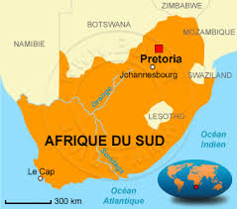
.

Capital of South Africa

Population and official languages

In South Africa there were 57 million people in 2018. There are a lot of languages. English is recognized as the language of commerce and science. At home most people speak Zulu, Xhosa and Africaans.

Nelson Mandela

Nelson Mandela was born in 1918 in a small village in southeast of South Africa. He was the first black president of South Africa. He stayed 27 years in prison. Robben Island (the prison of Nelson Mandela) is located in the South West of South Africa. He fought against racism in South Africa.
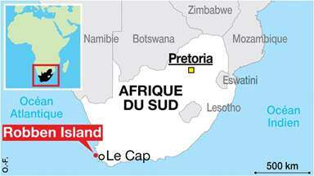
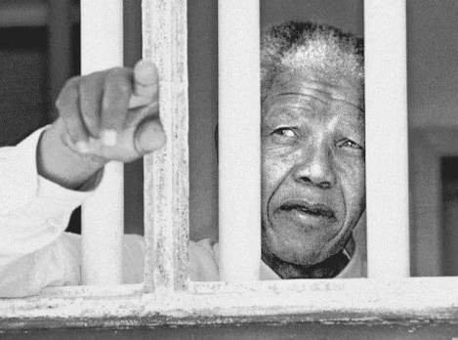

Robben Island is here
(prison of Nelson Mandela)
Nelson Mandela in jail
The flag of South Africa.

The flag of the Republic of South Africa was created in 1994. It’s blue, green, yellow, red, black and white. It is multi coulored and is a symbol for the rainbow nation.

The horizontal Y means the union of all its components.
Black means black people
Yellow means gold
Red means blood
Green means natural ressources
Blue means the shy and oceans.
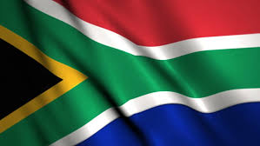
Flag of South Africa

Traditionnal food of South Africa.

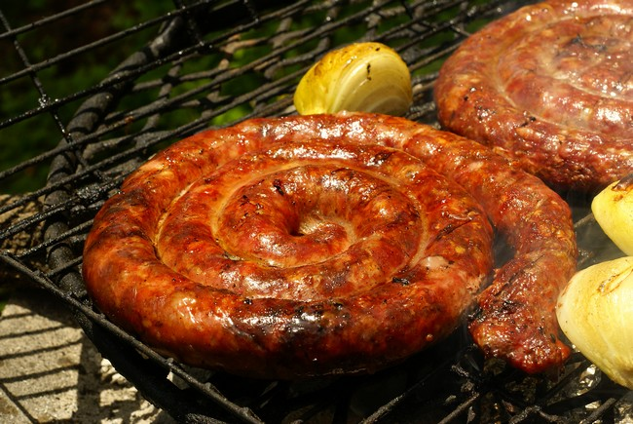
The Boerewors is a sausage of South Africa.

