THE YELLOW ACKERMAN
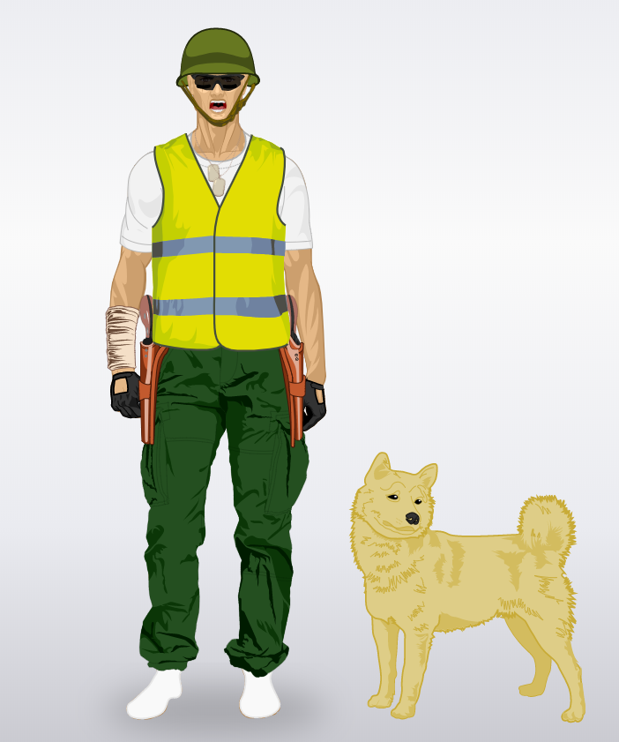
-He was born on 7 april 1781 in Houston
In the USA
-He lives in Paris
-he fights for the cause of the yellow
vests
-he has a dog is he best friend he
adopted him in 16 January 1817
he’s immortal like the yellow ackerman
-He discovered his superpowers in New
York after a fight with a member of
The Gouvernment.
-he wears a yellow vest, a green pants
and a green helmet like a military, he
has black gloves and he has a white
socks
-he’s very fast, he’s immortal, he can jump very very high, he can speak to animals and he can send a x-ray with he eyes.
-he has a lot of ennemis is the bad person of gouvernment because he hate a injustice
-he is very aggressive with people he doesn’t like.

Ryan and Watue

