his name is dark phenix. He loves to protect people
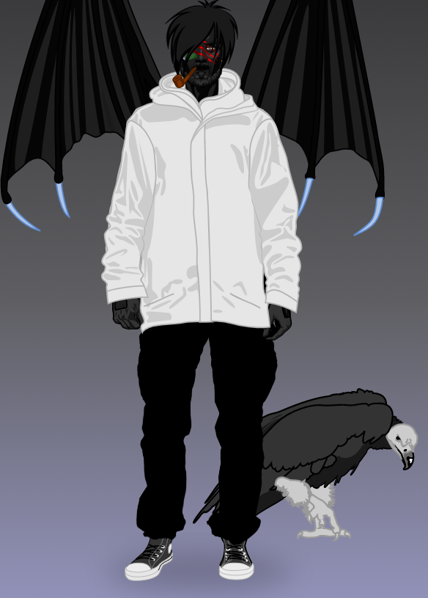
He was born in nouméa.
He became a superhero after an accident
Of car.
He discovered his superpowers one morning
In october.
He wears a white,black.
He is tall,muscular.
He dosn’t have a mask because he want to
See face.
He can fly because he have a wing and he is
Able to comunicate of animals.
His ennemies :
Leon jaye is a man he have a superpowers for do of bedly.
He wears a red,blue,white and black

Pierre 302

