ACE GUN WOMAN

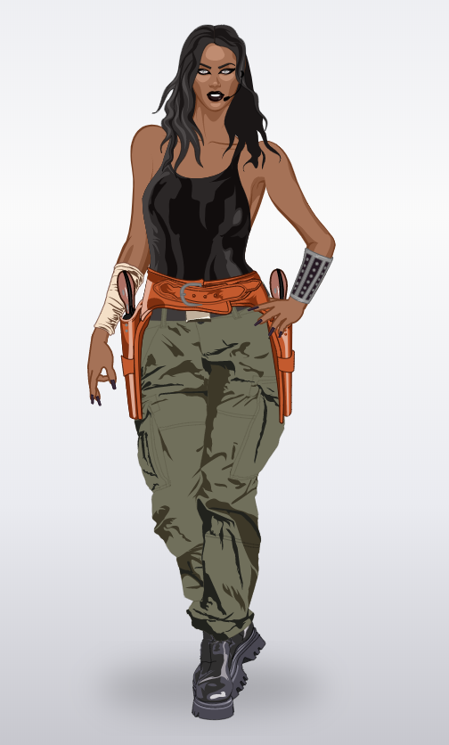
Superwoman is a girl and her name is Ace gun WOMAN. As the name suggests, she masters weapons to perfection. She has black wavy hair and she loves the black colour like, her makup, her shoes her nails and her boddy. She loves to carry khaki joggers and she prefer keep her gun around’s her height.
She was born in CALIFORNIA her mom is dead and her dad was a mafia and she was raised by her dad because he desire that his girl can self defend.

MORGANE and LOUANE

Sign :

