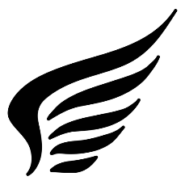
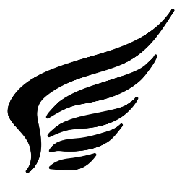
Volcania

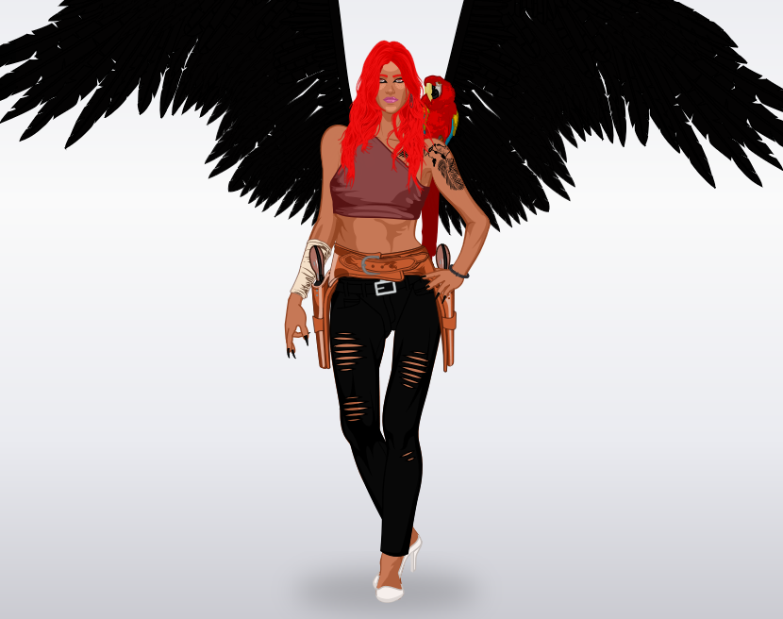
She was born in New-york.
She became a superhero when a volcano explosed.
She discovered her powers after the explosion.

She wears a purple top, a black jeans and white heels. Volcania has got red hair and long black nails. Her bestfriend is a parrot, its name is pearl.
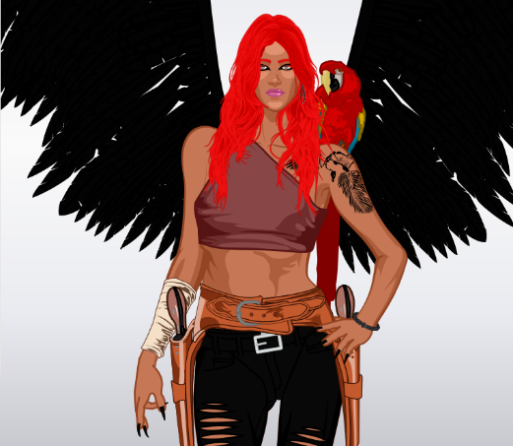
She has got wings. She is tall.Volcania can fly, run very fast
she is very agile.

Her mission is to save people who are in dangers, and kill villains

By Lisa & Ynes

