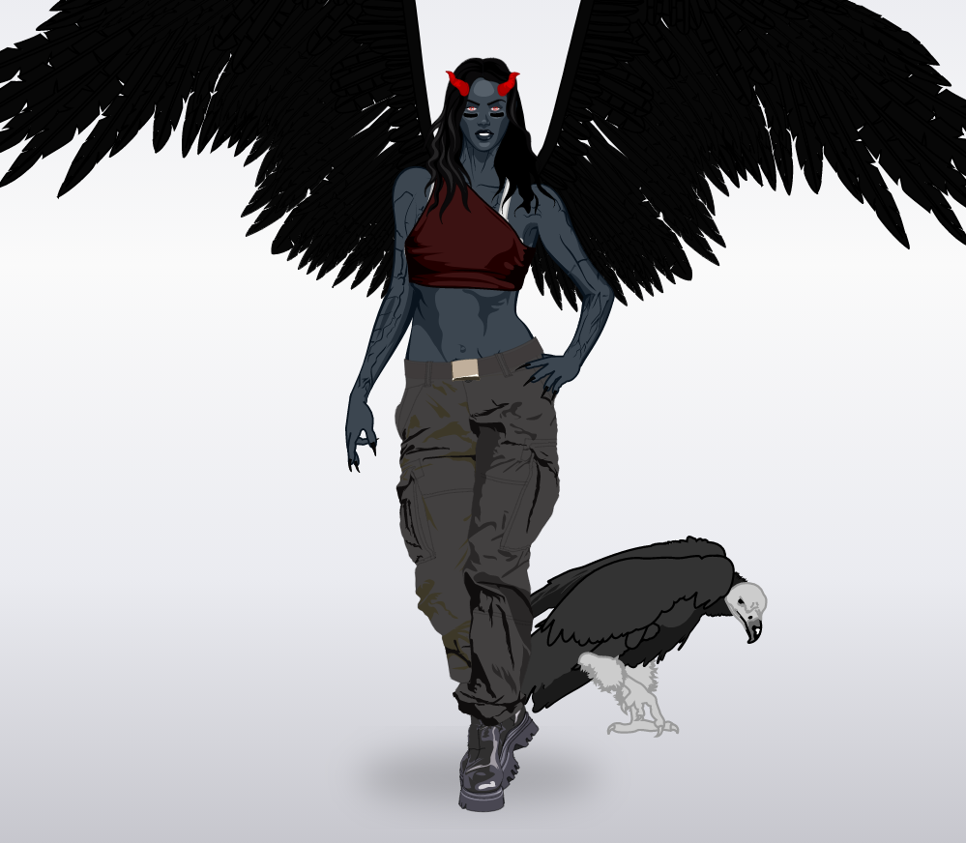
IRINA
NOEMIE 301
Demonia and Harpya

Ashley(Demonia) was born in California, she lives in New York.
At 15 she went for a walk in the forest and she met on an eagle to hurt and trying to heal him the eagle bit her. 1 week later she surrendered when there were bumps in her back with a horn on her face and she became a nastyhero.
PHYSICAL DESCRIPTION AND THE ANIMAL’S POWER :
She is wears of trousers and the crop top, her eyes is red, she is 2m06 tall. She is with her eagle, the claws of eagle have the superpower (poison).
HER SUPERPOWERS :
She can fly, She is able to do become a status with her eyes, she not able be invisible.
Her ennemies are Lyra the superpowers are be invisble and kill the people by think and Tryxie the superpowers are can fly and do the fire with her body.

