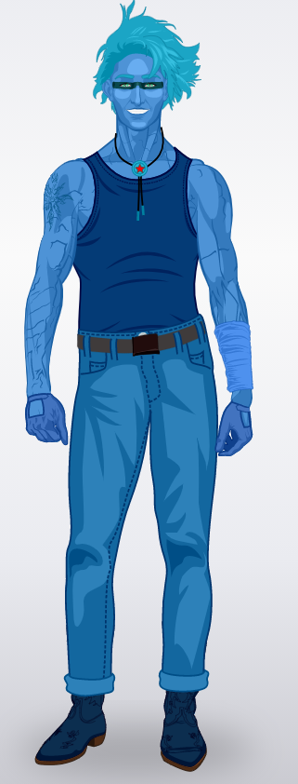 | Watt Err :  The human of water  Watt was born in California just as his parents and his brother. He discovered his powers after the explosion of his work place : a under water biolgic laboratory which was directed by his brother, a lot of water comes in his body, in his blood. Watt doesn’t wear a costume but he wears a blue T-shirt, a blue pant and a blue shoes. His body is blue, he has a tatoo on his right shoulder and a necklace around his neck. He is not very muscular, he is tall and his hair is blue. He has the ability to control the water, he can treat  himself with water and he is able to transform his body in water. His ennemy? His brother, Fy…  TO BE CONTINUED…
HUGO 301

