H O M Y C H I N A
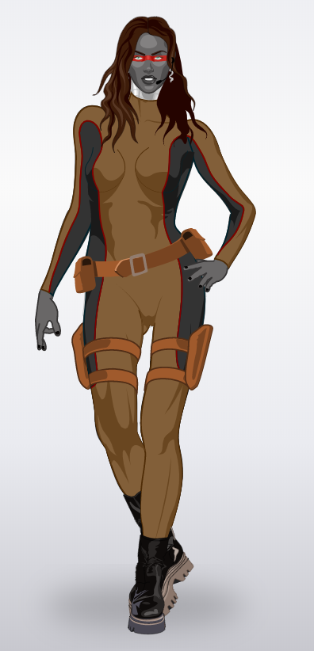 | Homy Anderson was born human but she had an accident . Vaki a bad man found Homy and he transformed her into a robot. She got a superpowers . she has the ability to fly who is able to telepathy. She has got a artificial intelligence .  Damaris et Rachel 301

