How to be safe online

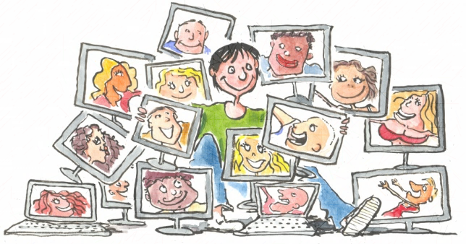
Advantages: on the internet, you can share photos, call with your friends, play with them, you can watch videos, learn things on the internet, connect to people and see what your friends are up to.

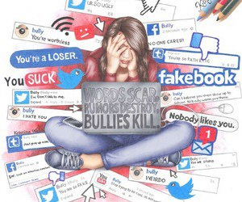
Dangers: You can be cyberbullied if you receive mean messages and if someone post embarrassing photos of you.
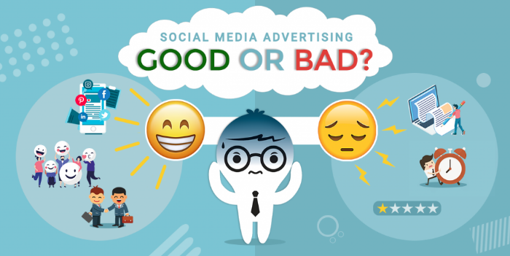
You can be hacked.

Advices: Instead of using your real name, you should use a pseudonym.
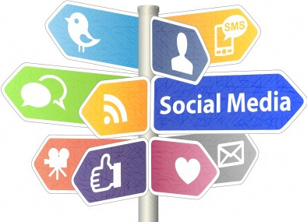
You shouldn’t use every time your phone or your computer. You should place limit for use social network. You mustn’t share your password with people.
You should be picky in choosing your online friends.

Guillaume et Hugo-301

