Welcome To South Africa

The South Africa is located in the South of the African continent. South Africa is bordered by the Atlantic ocean and the Indian ocean.
The Capital is named Pretoria but it has also got a nickname : « The city of Jacaranguas » because there are many beautiful trees in the city.
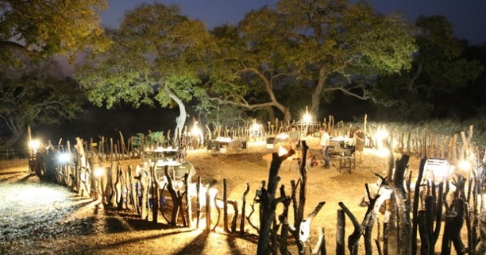
Kruger National Park
The Kruger Park is the best park of the africa continent in order to protect the wildlife the animals.
Pretoria
(Or « The City of Jacaranguas ») is the capital of the South Africa, because there are many beautiful trees in the city.
C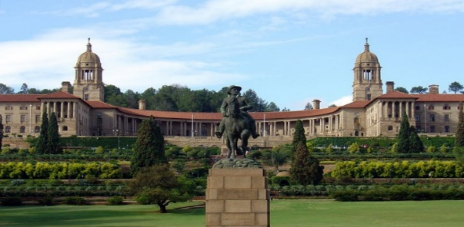
Johannesburg
(Or « The City of Gold ») is a big city in South Africa and one of the 50 largest urban areas in the world. Is the actually capital of the province of Gauteng, the richest in South Africa.
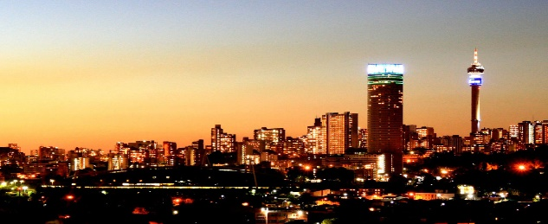

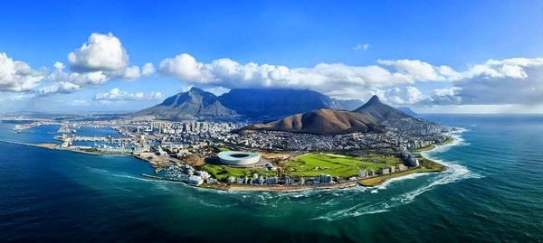
Cape Town
Cap Town is the second most populous city in South Africa after Johannesburg and also the legislative capital of South Africa.

