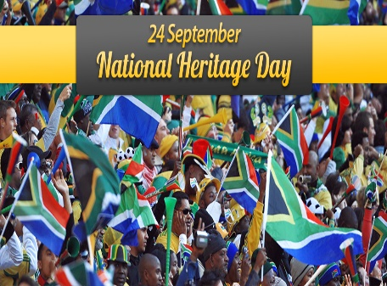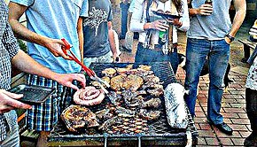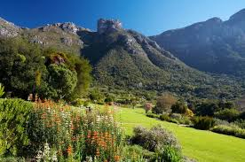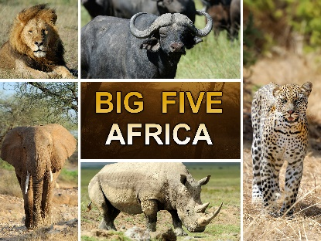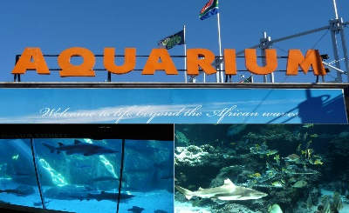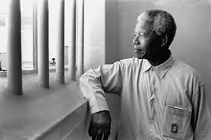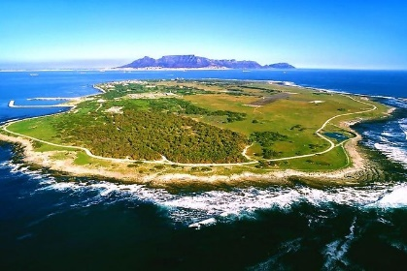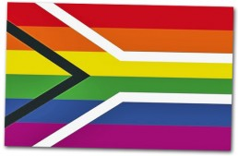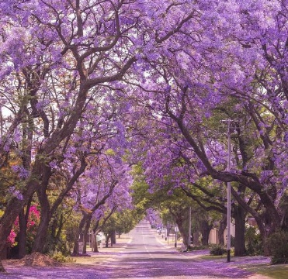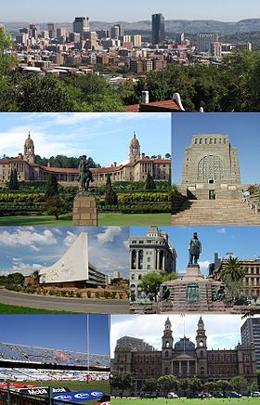

Braai it’s South African Barbecue

Two Oceans Aquarium

Kirstenbosch garden

Come visit Cape Town City

Cape Town City is located in the South-East of the South Africa. You can visit Two Oceans Aquarium and the Kirstenbosch garden.

Come enjoy a safari

Kruger National Park is a very popular park because you can see wild animals, like a lion, leopard, rhino, buffalo, and elephant

Nelson Mandela

Robben Island

Come in Robben Island

Robben Island is where Nelson Mandela was imprisoned. This old jail became a museum.

Come and spend a day in Pretoria

Pretoria is a capital of South Africa. Her nickname is « city of Jacaranguas ». There are many beautiful trees.

**WELCOME TO THE RAINBOW NATION**

*Enora et Ludovic*

Pretoria city

Jacaranguas in Pretoria

Come play during Heritage Day

Heritage Day is a cultural fair in South Africa. It’s celebrate on September 24th. People dance, sing, wear traditional outfits, eat braai…