XENOZ 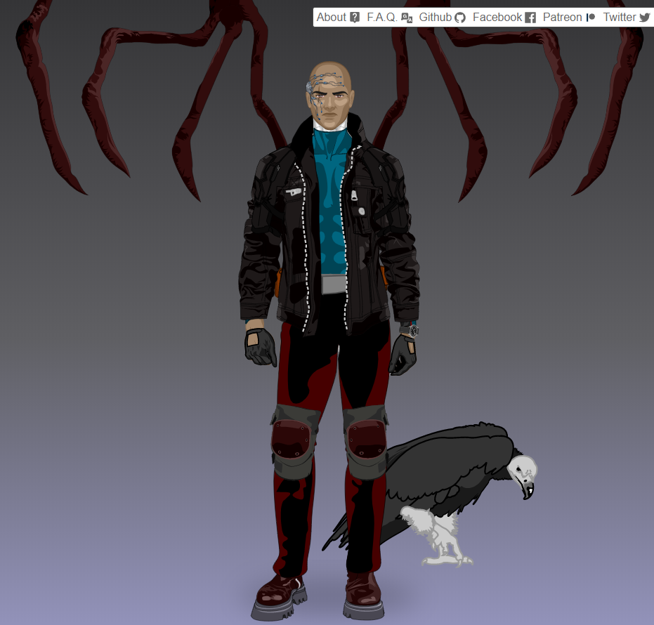

Xenoz is a super villain who likes to control machines to annihilâte this ennemies. He was born in Russia in Moscow on october 1975. He killed his family accidently when he was 6 years , and after that he decided to live alone for a moment .

He got his powers when he was 5 years in a laboratory ; he fall into an wine Radioactive and after that he has the ability to control machines and climb walls and fly with retractable wings .

This is how he discovers his powers . He wears an black jacket and under jacket he wear blue t-shirt , thats boot is red this pant is red . He is able to control vehicule and all machin if he want , he can make accident happend . He has a pet , this pet is an crow . his name is falco .

Illies 302

Illiès

by ilies 302