TRYXIE
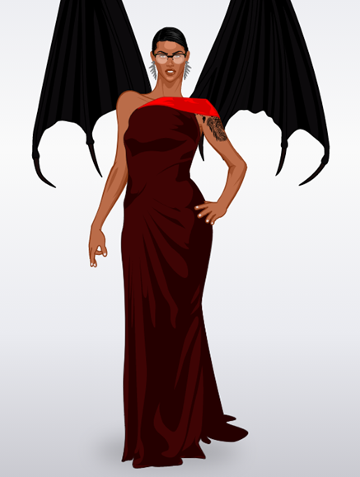
Trixie is a very beautiful girl and demon. She has a superpowers and she ate the devil fruit to get they. She is able to make fire with her hands. She can fly with her wings which are black.
Tryxie wears a red dress, has glasses, earings. She has short black hair and a tatoo on her arm.
She was born in the planet Odika, her parents are dead because Syd attacted they. Syd is a centaur but she can transform her body and now Tryxie want kill her.

Chloey & Cenderella

