SPRINGBOK :South African rugby team
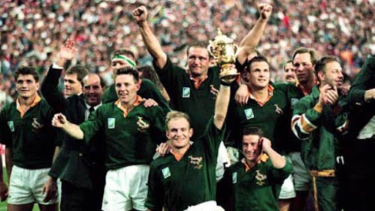
The springboks won against the all blacks in 1995 at the world cup
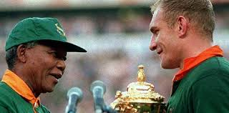
Nelson Mandela attended the match
-The victory of the springboks

