WELCOME TO SOUTH AFRICA

South Africa is located in the south of African continent. The capital is Pretoria but the most famous city is Johannesburg. The first black president of the South Africa is Nelson Mandela.

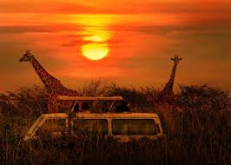
-Kruger National park:
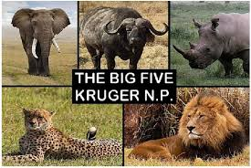
You will can see the “big five” (lion, buffalo, cheetah, rhino, elephant) in a safari.

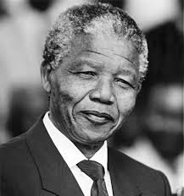
-Nelson Mandela:
He was the first black president of South Africa. He stayed 27 years in prison because he fought against racism.
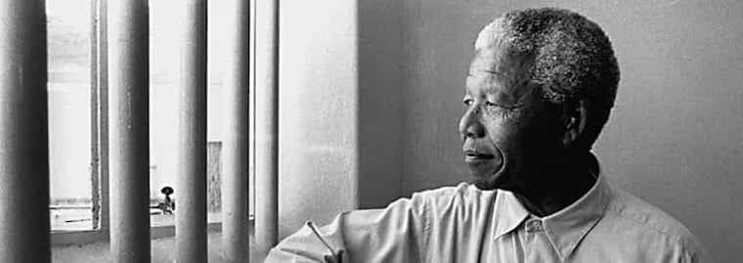

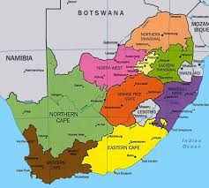
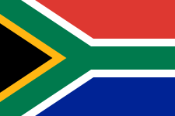
Where is South Africa?
South Africa is located in the south of African continent.

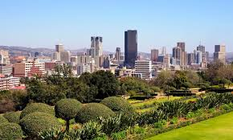
Pretoria:
His nickname is “The city of Jacaranguas” Pretoria is located in the north of Johannesburg.

Heritage Day:
Heritage Day is a South African public holiday, honouring the culture and diversity of beliefs and traditions of all South Africans. Celebrated each year on September 24, the day serves as a reminder that the nation belongs to its entire people.

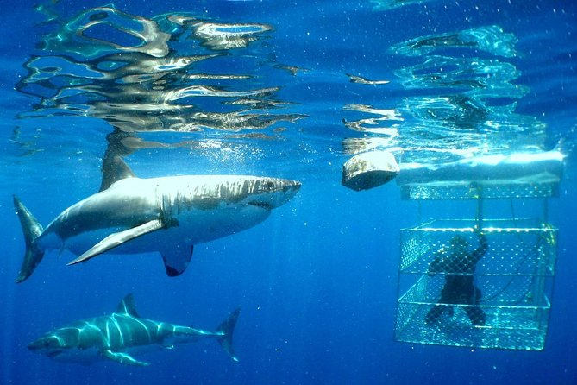
Activities:
-Choose to get down in the water with the sharks in a cage or enjoy the show from the decks of the boat on this dive tour from Cape Town.

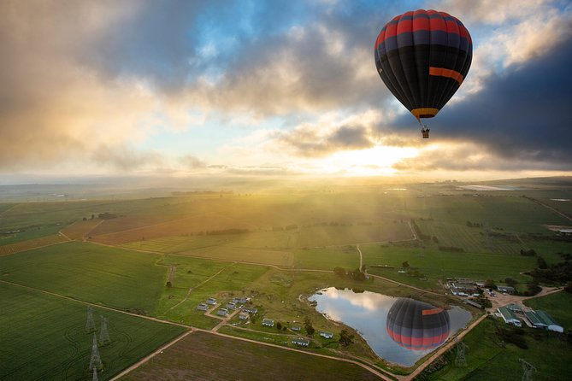
-Get a brand new perspective on Cape Town and see sunrise over Table Mountain without the crowds (or waiting in line for the cable car) on this hot air balloon ride in the Cape Winelands.

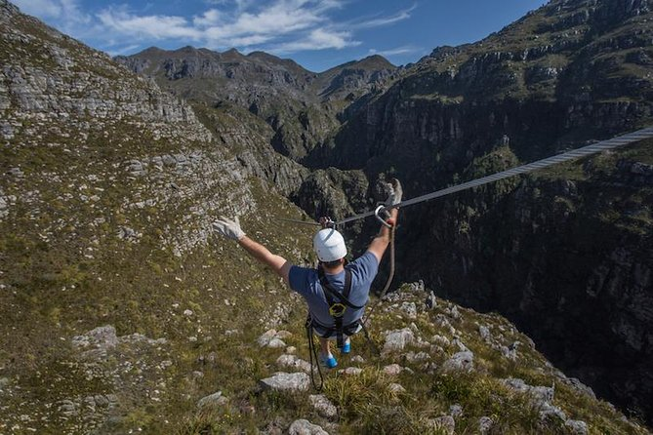
-Combine a zipline adventure with an educational session on cheetahs and wine tasting during this 8-hour tour from Cape Town.
Evan et Yanu 403

